Proof of Concept: Workload Identity Federation between Google Cloud and Microsoft Entra ID

Contents
Proof of Concept: Workload Identity Federation between Google Cloud and Microsoft Entra ID 1
1. Overview of Workload Identity Federation 1
2. Overview of POC 2
3. Config parameters 2
4. Prerequisites 3
5. Google Cloud Project and Identity Setup 4
6. Entra ID Configuration 6
7. JWT Assertions 7
8. Local Environment Setup 8
9. Cloud Run Deployment 9
10. Workload Identity Federation Setup (GCP Side) 9
11. Postman Request for local testing 10
12. Spring Boot App 10
13. Demo Flow 12
14. Sanitization Note & Screenshots 12

Overview of Workload Identity Federation
Workload Identity Federation (WIF) removes the need for long-lived secrets when connecting GCP workloads to Microsoft Entra ID, offering strong security and operational benefits.
Benefits of Workload Identity Federation
- No long-lived secrets
Applications don’t need to store client secrets or certificates. Tokens are minted dynamically, reducing risk of leakage Microsoft Learn LinkedIn.
- Improved security posture
Trust is established via short-lived JWT assertions. This minimizes attack surface compared to static credentials Microsoft Learn.
- Cross-cloud interoperability
Enables workloads in GCP (Cloud Run, GKE, Cloud Functions) to securely access Microsoft Entra-protected resources like Graph API, without duplicating identities Microsoft Learn Aembit.
- Scalability and automation
Works well for CI/CD pipelines (e.g., GitHub Actions, Kubernetes workloads) where secret management is difficult Microsoft Learn.
- Granular access control
You can scope federated credentials to specific service accounts, audiences, and subjects, ensuring least-privilege access.

Overview of POC
This proof-of-concept demonstrates how a Google Cloud service account federates with Microsoft Entra ID to obtain an access token for Microsoft Graph. The application is hosted on Cloud Run and exposes a simple UI to query Graph /users.

Config parameters
Below are the required parameters that are required for the setup. How to get them are explained in later sections.
Required config values:
- GCP Deployed App URL: <cloudRunAppUrl>
- Entra Tenant ID: <tenantId>
- Entra App registration Client ID: <clientId>
- Service Account: <serviceAccountEmail>
- Audience: <audience>
- Issuer: <issuer>
- Workload Identity Pool ID: <pool>
- Provider ID: <provider>
- GCP Project ID: <projectId>
- GCP Project Number: <projectNumber>

Prerequisites
Google Cloud
- Project: <projectId>
- Spring boot app deployed in Google Cloud Run as a service with token handling and MSGraph Query logic
- Service Account: <serviceAccountEmail>
- Workload Identity Pool: <pool>
- Workload Identity Provider: <provider>
- Roles:
  - roles/iam.serviceAccountTokenCreator for Cloud Run service account
  - roles/run.admin for deployment
Microsoft Entra ID
- Tenant: <tenantId>
- App Registration: <clientId>
- Federated Credential configured with:
  - Issuer: <issuer>
  - Subject: <serviceAccountSub>
  - Audience: <audience>
- API Permissions:
  - User.Read.All (application permission) for Microsoft Graph
  - Admin consent granted for the API

Google Cloud Project and Identity Setup
Google Cloud CLI (gcloud) commands are provided for each step.
Create a New Project
# Create a new project
gcloud projects create <projectId> \
--name="<Project Display Name>" \
--set-as-default

# Link billing account (replace with your billing account ID)
gcloud beta billing projects link <projectId> \
--billing-account=<billingAccountId>

Create a Service Account
# Create service account
gcloud iam service-accounts create <serviceAccountName> \
--project=<projectId> \
--display-name="Federation Service Account"
The service account email will be:
<serviceAccountName>@<projectId>.iam.gserviceaccount.com

Enable IAM Credentials API
Before minting ID tokens, enable the IAM Credentials API:
gcloud services enable iamcredentials.googleapis.com \
--project=<projectId>

Assign Roles to Service Account
Grant the service account the ability to mint ID tokens:
# Allow service account to mint tokens
gcloud projects add-iam-policy-binding <projectId> \
--member="serviceAccount:<serviceAccountName>@<projectId>.iam.gserviceaccount.com" \
--role="roles/iam.serviceAccountTokenCreator"

If you’re testing locally, also grant your user account this role on the service account:
gcloud iam service-accounts add-iam-policy-binding \
<serviceAccountName>@<projectId>.iam.gserviceaccount.com \
--project=<projectId> \
--role=roles/iam.serviceAccountTokenCreator \
--member=user:<yourUserEmail>

Create Workload Identity Pool
# Create a workload identity pool
gcloud iam workload-identity-pools create <poolName> \
--project=<projectId> \
--location=global \
--display-name="Federation Pool"

Create OIDC Provider with Custom Audience
# Create OIDC provider
gcloud iam workload-identity-pools providers create-oidc <providerName> \
--project=<projectId> \
--location=global \
--workload-identity-pool=<poolName> \
--display-name="Federation Provider" \
--issuer-uri="https://accounts.google.com" \
--allowed-audiences="<customAudience>"
- Issuer URI: https://accounts.google.com (for GCP service accounts)
- Allowed Audience: <customAudience> (must match what you configure in Entra federated credential)

Bind Service Account to Pool Subject
# Bind service account to workload identity pool subject
gcloud iam service-accounts add-iam-policy-binding \
<serviceAccountName>@<projectId>.iam.gserviceaccount.com \
--project=<projectId> \
--role="roles/iam.workloadIdentityUser" \
--member="principal://iam.googleapis.com/projects/<projectNumber>/locations/global/workloadIdentityPools/<poolName>/subject/<serviceAccountSub>"
- <serviceAccountSub> is the sub claim from the GCP ID token.
- This binding allows Entra to trust the GCP service account identity.

Summary of the steps
- Project created and billing linked.
- Service account created and granted token-minting rights.
- Workload Identity Pool and OIDC provider set up with custom audience.
- Binding established between service account and pool subject.

Entra ID Configuration
Create App Registration
- Navigate to Azure Portal → Entra ID → App registrations.
- Click New registration.
- Enter:
  - Name: <appDisplayName>
  - Supported account types: Single tenant
  - Redirect URI: leave blank for app-only scenario.
- Save and note the Application (client) ID <clientId>.
Configure Federated Credential
- In the App Registration, go to Certificates & secrets → Federated credentials.
- Click Add credential.
- Select Other Issuer as the Federated credential scenario.
- Enter:
  - Issuer: <issuer> (e.g. https://accounts.google.com)
  - Subject: <serviceAccountSub> (from GCP ID token sub)
  - Audience: <audience> (must match what GCP ID token uses)
- Save.
Expose Graph API
- In the App Registration, go to API permissions.
- Click Add a permission → Microsoft Graph → Application permissions.
- Select User.Read.All.
- Click Grant admin consent.
Verify Token Issuance
- Use Postman or your app to exchange GCP ID token with Entra.
- Confirm Entra issues an access token with aud=https://graph.microsoft.com.

JWT Assertions
Below are the JWT assertion values that you would get during the requests.
GCP ID Token
{
"aud": "<audience>",
"azp": "<serviceAccountSub>",
"exp": <exp>,
"iat": <iat>,
"iss": "<issuer>",
"sub": "<serviceAccountSub>"
}
Entra Access Token
{
"aud": "https://graph.microsoft.com",
"iss": "https://sts.windows.net/<tenantId>/",
"appid": "<clientId>",
"idtyp": "app",
"oid": "<objectId>",
"sub": "<objectId>"
}

Local Environment Setup
In your Code Environment, run this in terminal:
Authenticate with GCP
gcloud auth login
gcloud config set project <projectId>
Impersonate Service Account
gcloud auth application-default login \
--impersonate-service-account=<serviceAccountEmail>
Build & Run Spring Boot App
mvn clean package
mvn spring-boot:run
Access at http://localhost:8080.

Cloud Run Deployment
Build and Push Image (From the local code editor terminal)
gcloud builds submit --tag gcr.io/<projectId>/cloudrun-federation
Deploy
gcloud run deploy cloudrun-federation \
--image gcr.io/<projectId>/cloudrun-federation \
--platform managed \
--region asia-south1 \
--service-account=<serviceAccountEmail> \
--allow-unauthenticated
Verify
gcloud run services describe cloudrun-federation --region asia-south1

Workload Identity Federation Setup (GCP Side)
Create Pool
gcloud iam workload-identity-pools create <pool> \
--project=<projectId> \
--location=global \
--display-name="Federation Pool"
Create Provider
gcloud iam workload-identity-pools providers create-oidc <provider> \
--project=<projectId> \
--location=global \
--workload-identity-pool=<pool> \
--display-name="Federation Provider" \
--issuer-uri=<issuer> \
--allowed-audiences=<audience>
Bind Service Account
gcloud iam service-accounts add-iam-policy-binding <serviceAccountEmail> \
--project=<projectId> \
--role=roles/iam.workloadIdentityUser \
--member="principal://iam.googleapis.com/projects/<projectNumber>/locations/global/workloadIdentityPools/<pool>/subject/<serviceAccountSub>"

Postman Request for local testing
Import the below collection file in Postman:
Screenshots:
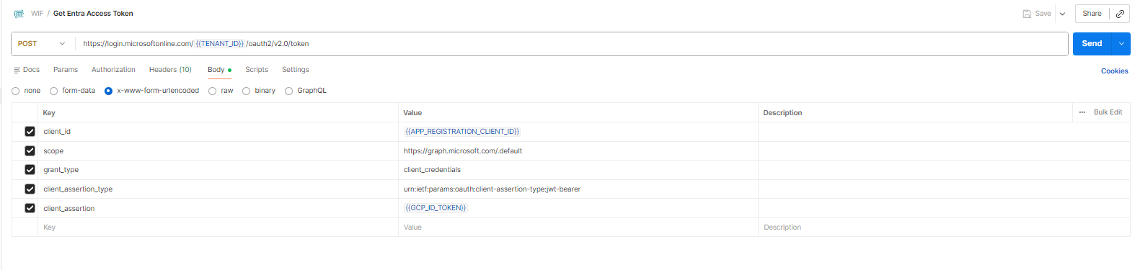
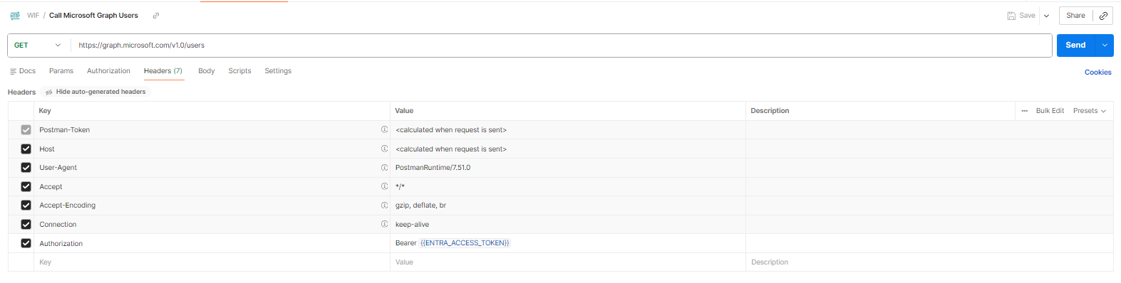

Spring Boot App
Folder structure:
cloudrun-federation-app/
├── pom.xml # Maven build file with dependencies
├── .env # ENV file for static values
└── src/
└── main/
├── java/
│ └── com/example/cloudrunfederation/
│ └── CloudRunFederationApp.java # Single class containing main app, controller, federation logic, and sanitization
└── resources/
└── application.properties # (empty or optional)

Key Components:
Since everything is in one file, this class handles multiple roles:
- Entry Point
Annotated with @SpringBootApplication and contains the main() method.
- Controller
Annotated with @RestController.
  - / endpoint → returns HTML UI with banner, button, and output box.
  - /query endpoint → performs federation flow and returns sanitized Graph JSON.
- Federation Logic
Inside /query, the class:
  - Mints a GCP ID token using GoogleCredentials and IdTokenCredentials.
  - Exchanges token with Microsoft Entra ID via OAuth2 token endpoint.
  - Calls Microsoft Graph API with the issued access token.
- Sanitization
Contains helper methods to mask sensitive fields (emails, phones, IDs, names) before returning JSON.

Execution Flow
- User opens / → sees banner and button.
- Button triggers /query.
- CloudRunFederationApp.java mints GCP ID token → exchanges with Entra → calls Graph /users.
- Sanitization logic masks sensitive fields.
- Sanitized JSON returned and displayed in the UI.

Individual files:
.env content:
  - TENANT_ID=<your-tenant-id>
  - APP_CLIENT_ID=<your-app-registration-client-id>
  - GOOGLE_AUDIENCE=<your-custom-audience>

Demo Flow
- User clicks Query Users in the deployed Spring Boot endpoint in GCP.
- App mints a GCP ID token (aud=<audience>).
- Token exchanged with Entra via federated credential.
- Entra issues Graph access token (aud=https://graph.microsoft.com).
- App calls Graph /users, sanitizes output for that endpoint, and displays JSON.

Sanitization Note & Screenshots
In the Spring Boot App: For demo purposes, sensitive fields (emails, phone numbers, IDs, UPNs) are masked with placeholders like ### or xx. The JSON structure remains intact to illustrate the federation flow without exposing private data.
Sample Screenshots:
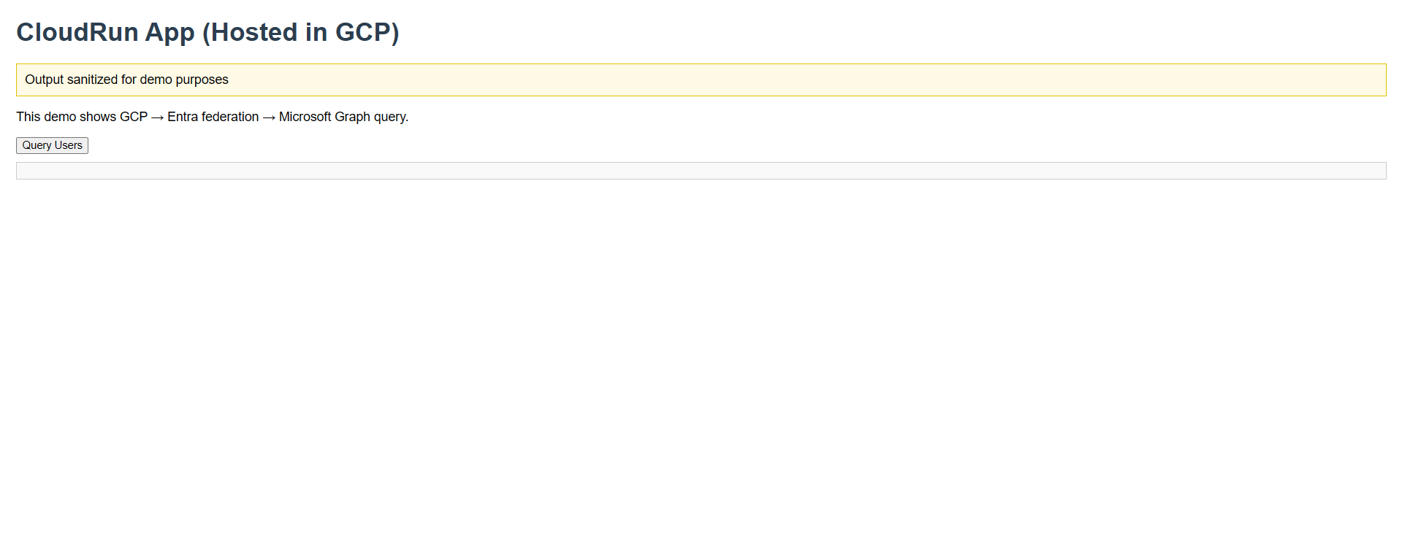
On clicking the Button:
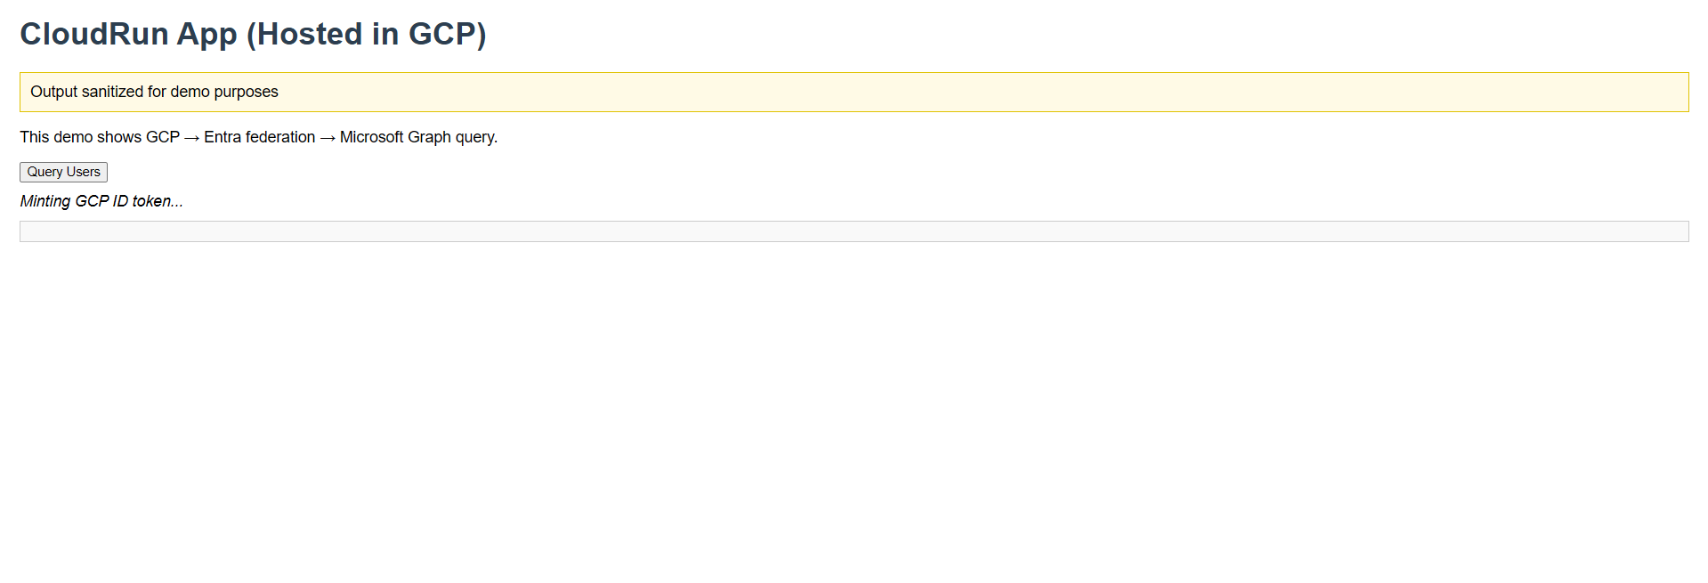
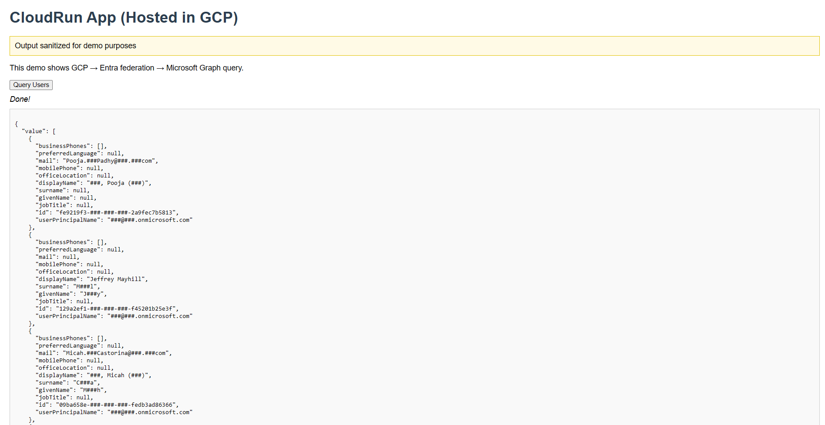
As shown here, this is just a Proof-of-concept for the Workload Identity Federation and this can be extended to various use cases.

